INFO531/ISTA431: Week 12 Assignment
Topic: Data Collection & Storage Using Python
Assignment Instructions: Answer the following questions and provide each
question, screenshots, code, and results in a Word document or PDF file. Any
screenshot provided, must be readable. Grade points: 100 (10 points for each
question).
NOTE-1
: Show the screenshot of a successful installation of Anaconda with the latest version of Python
(Python 3.8 or a later version) on your machine. Link:
https://www.anaconda.com/products/individual
NOTE-2
: Anaconda Navigator allows users to launch applications including Jupyter Notebook (a web-
based, interactive computing notebook environment) and Spyder (a scientific Python development
environment).
You will need to use Jupyter Notebook to do this assignment
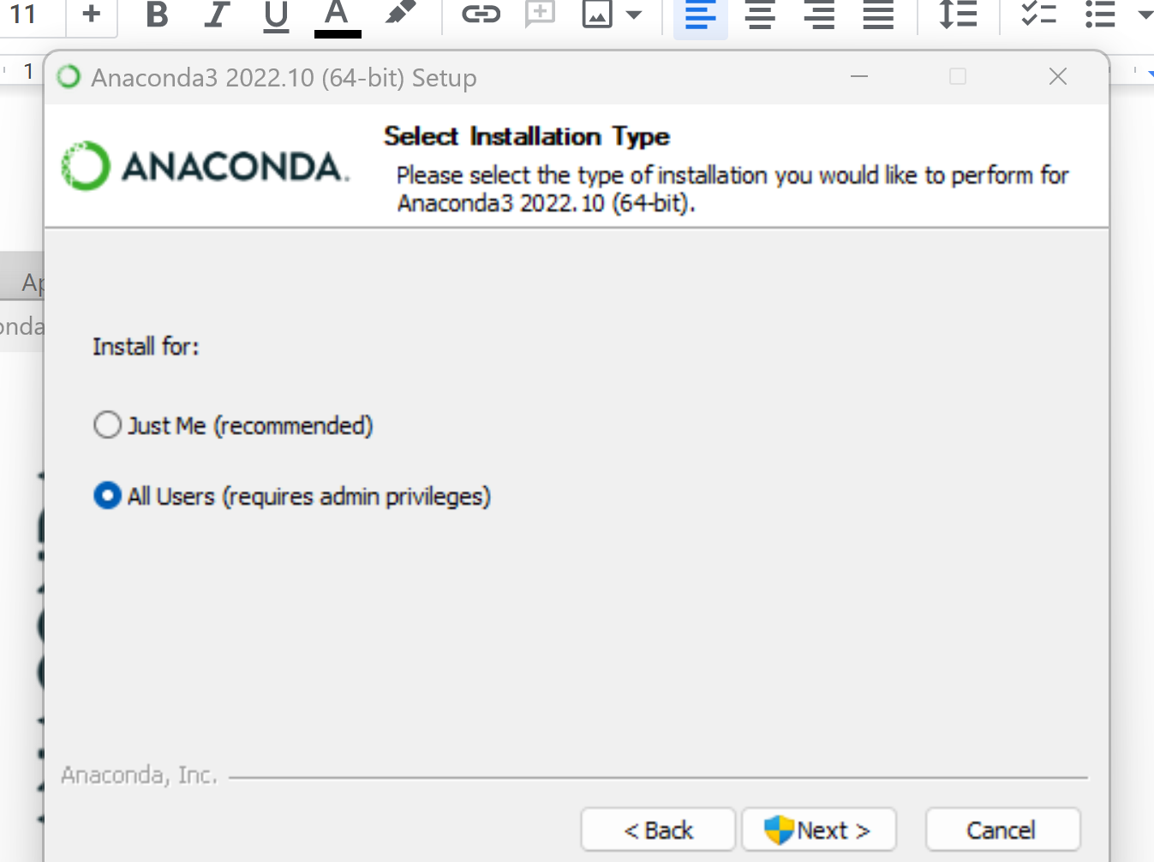

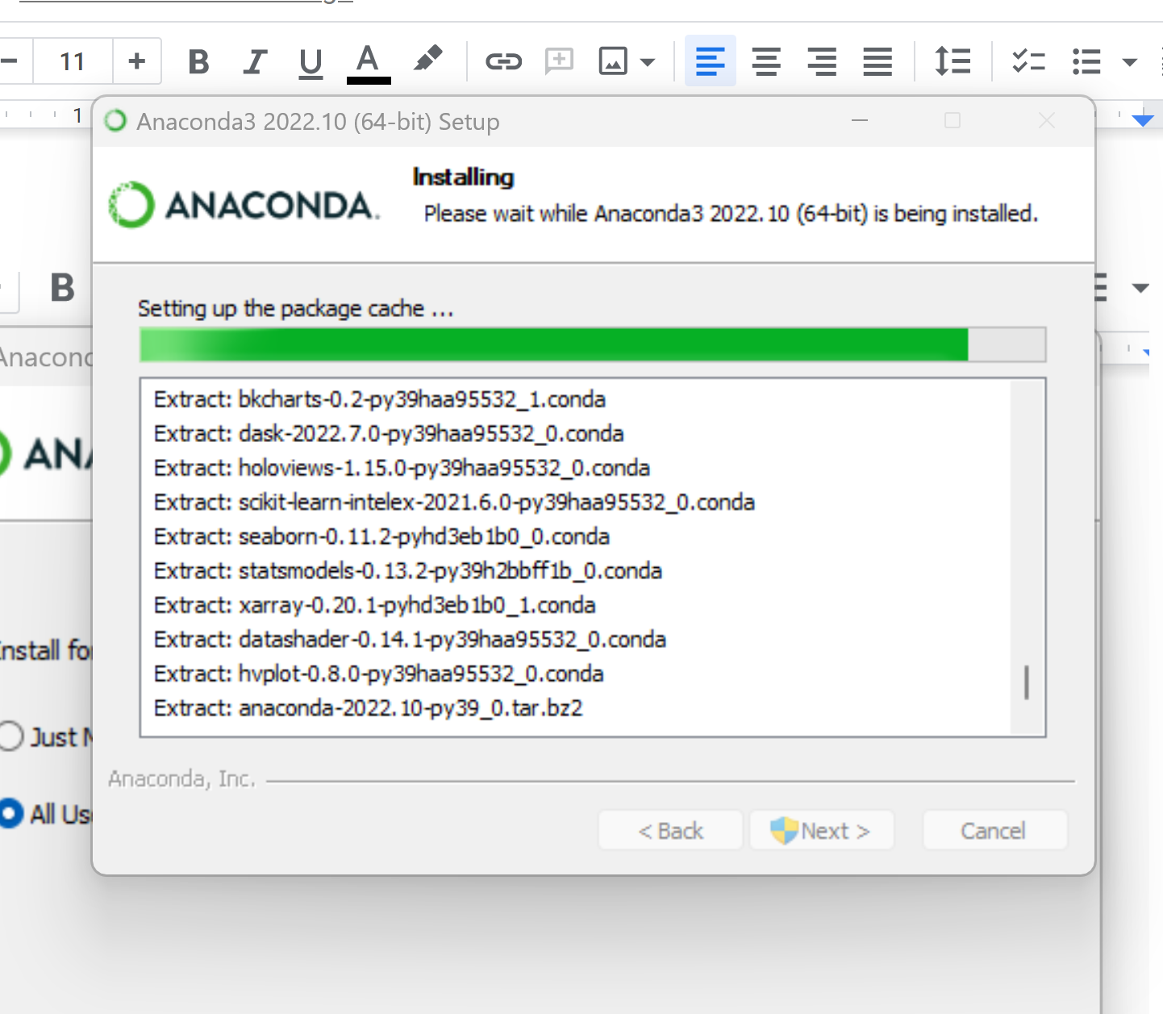

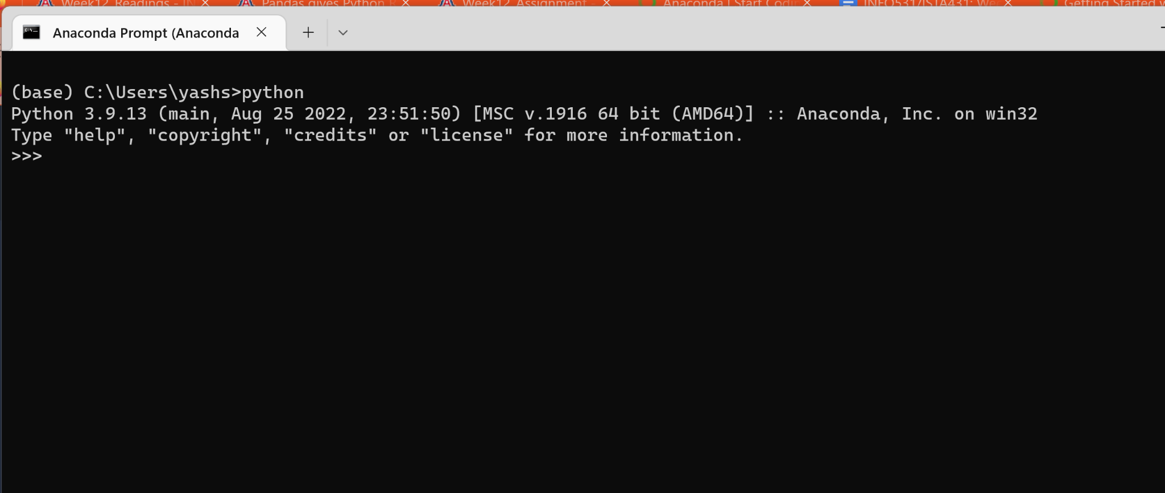
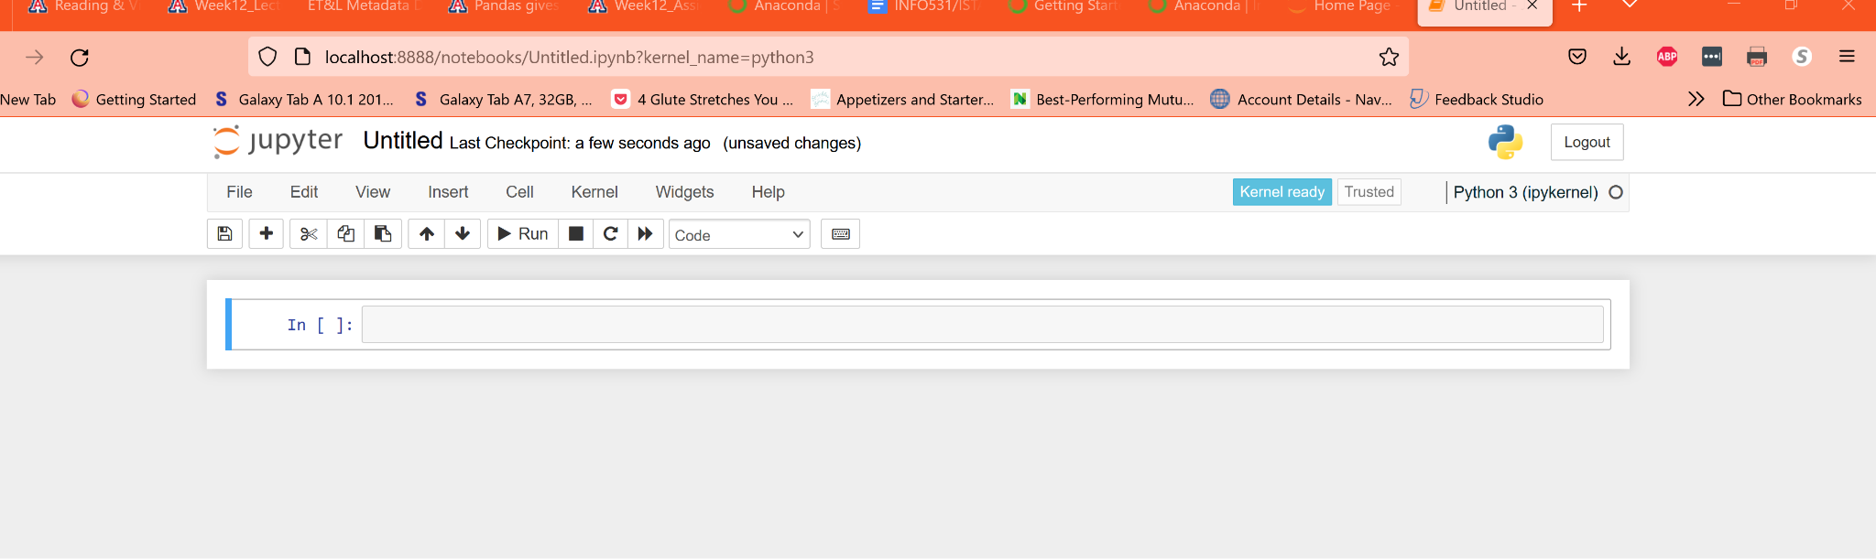

(1)1. Create an instance of a Pandas DataFrame using the DataFrame constructor with data from a Python nested dictionary. Show the code and display the first few rows.
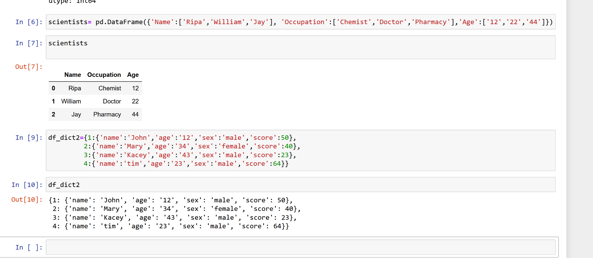

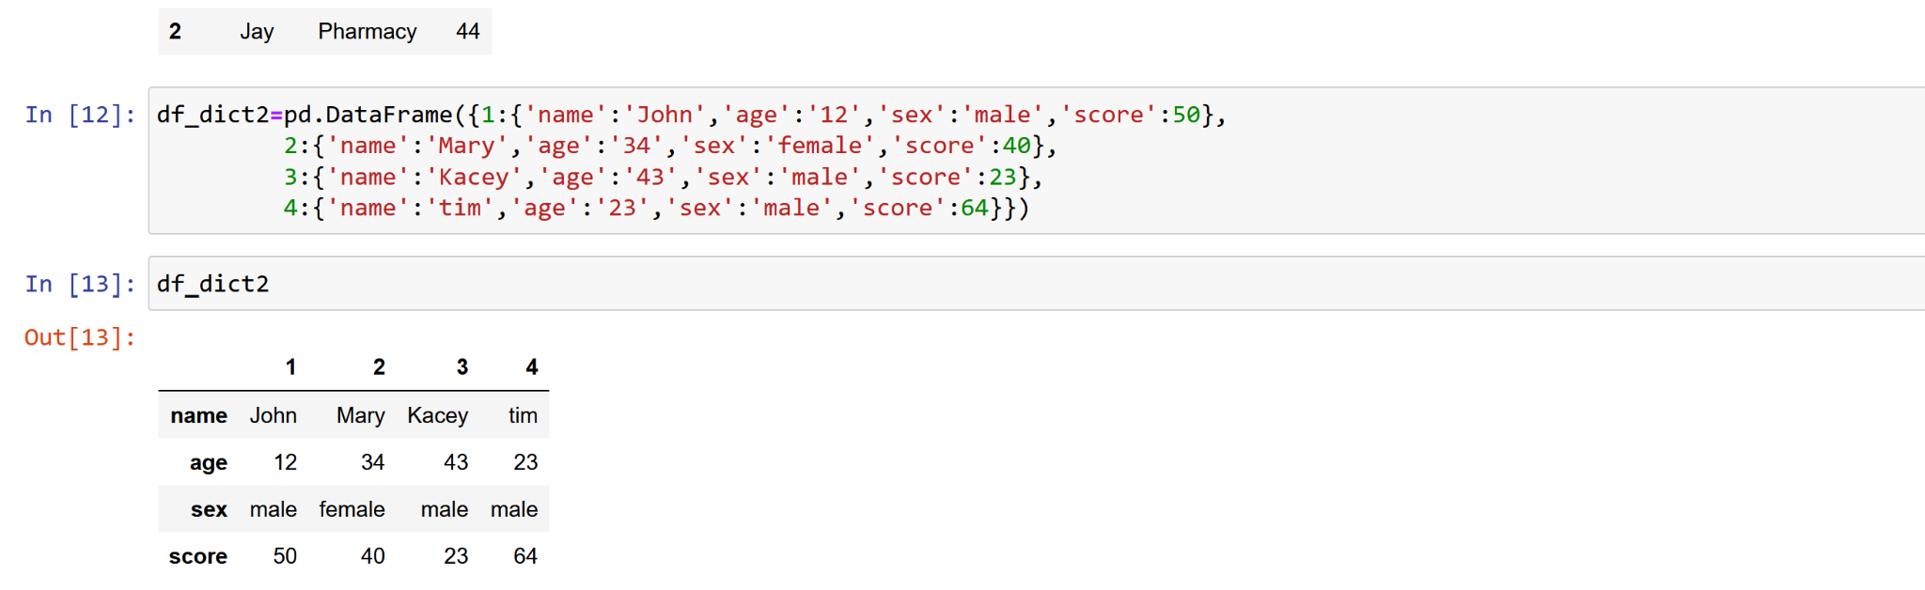
(2)You have created an instance of Pandas DataFrame in #1 above. Now, save your Pandas DataFrame as a CSV file with .to_csv(). Show the code. Verify the data.csv file created on your C drive! Show the screenshot and display first few rows.

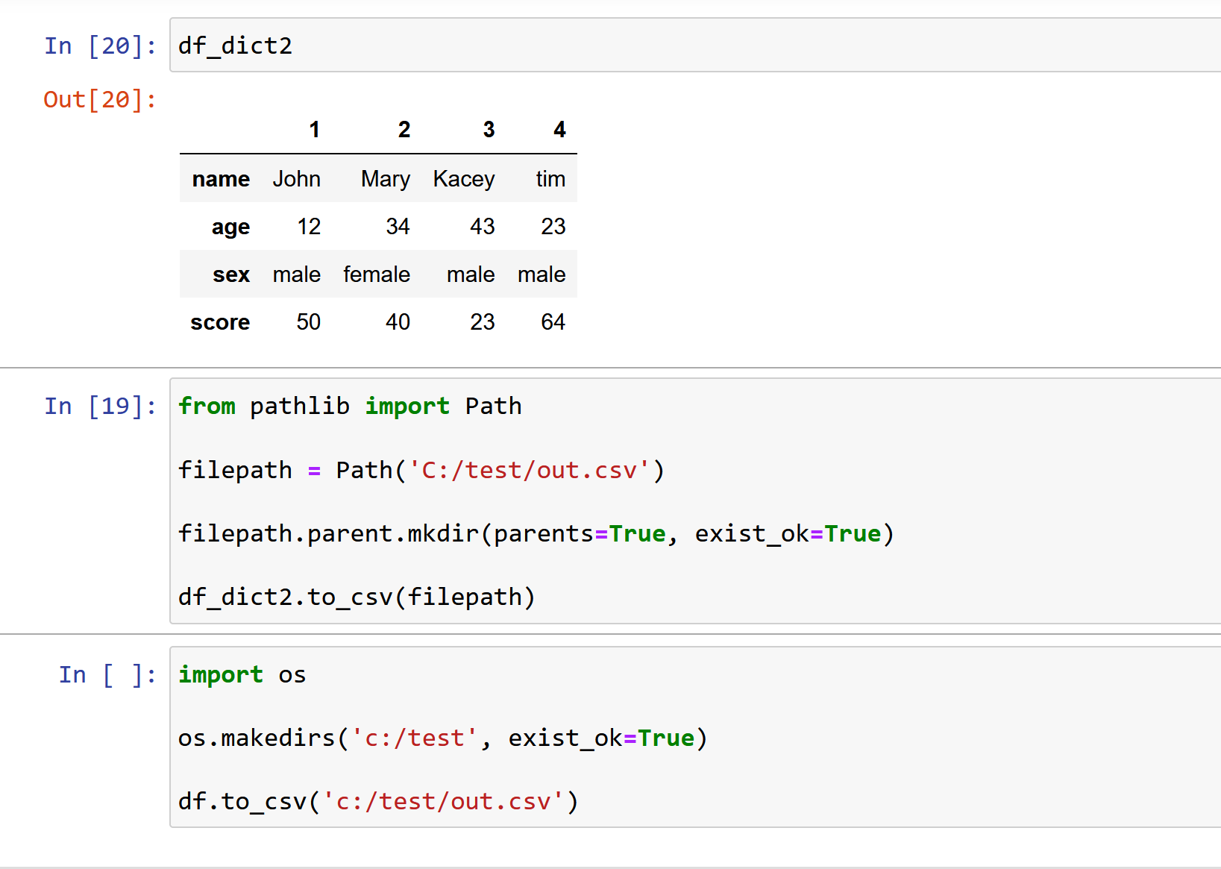
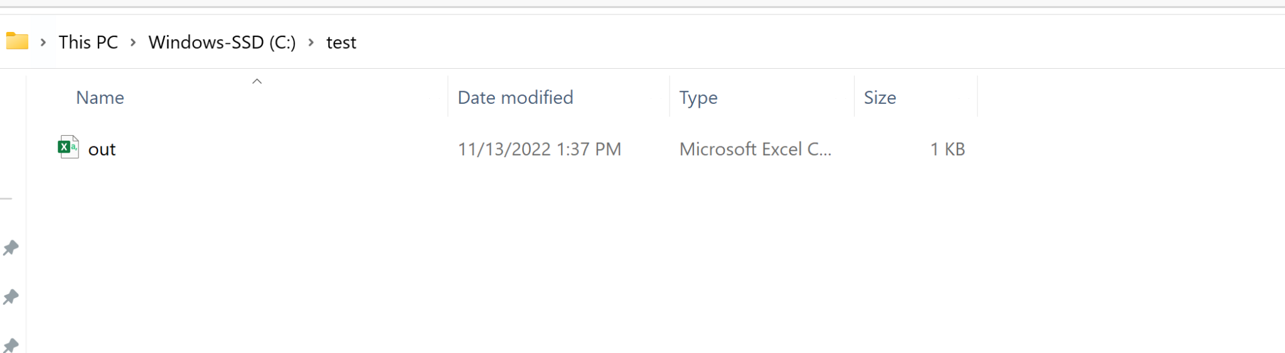

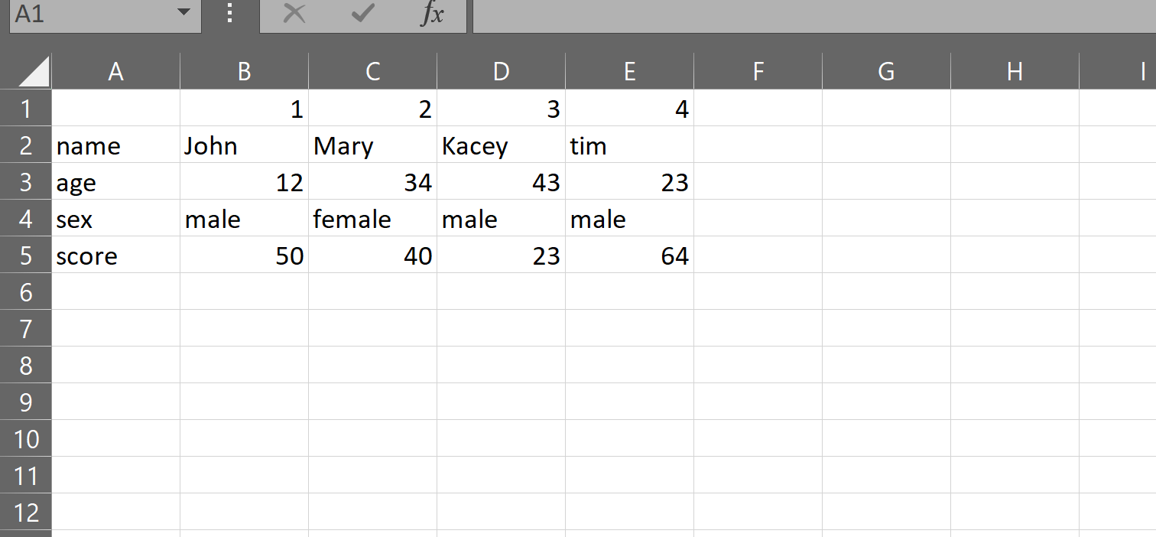

3. You have created a CSV file in #2 above. Now, import data back to Pandas DataFrame using Pandas read_csv() function and adding the index_col as a parameter. Show the code and display first few rows.

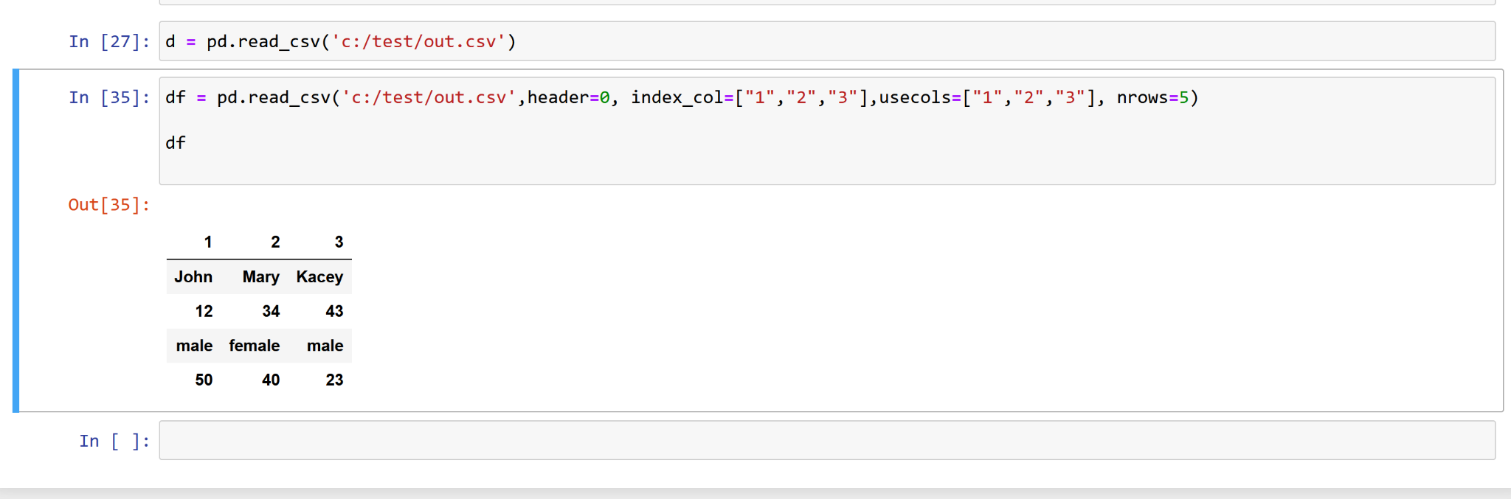

4. You have created an instance of Pandas DataFrame in #1 above. Now, save your Pandas DataFrame in an Excel file with .to_excel(). Show the code. Verify the data.xlsx file created on your C drive! Show the screenshot and display first few rows.

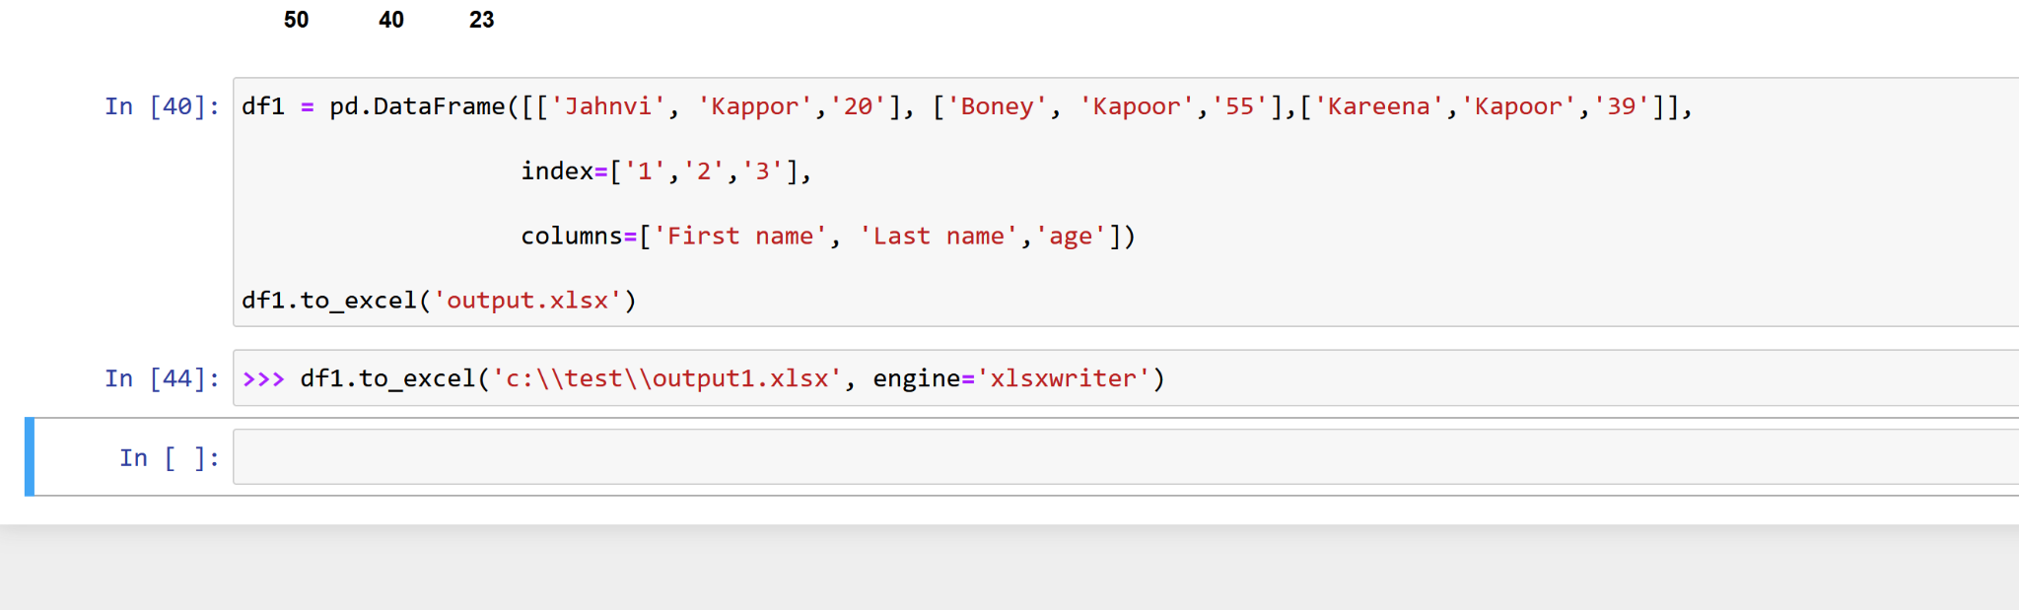
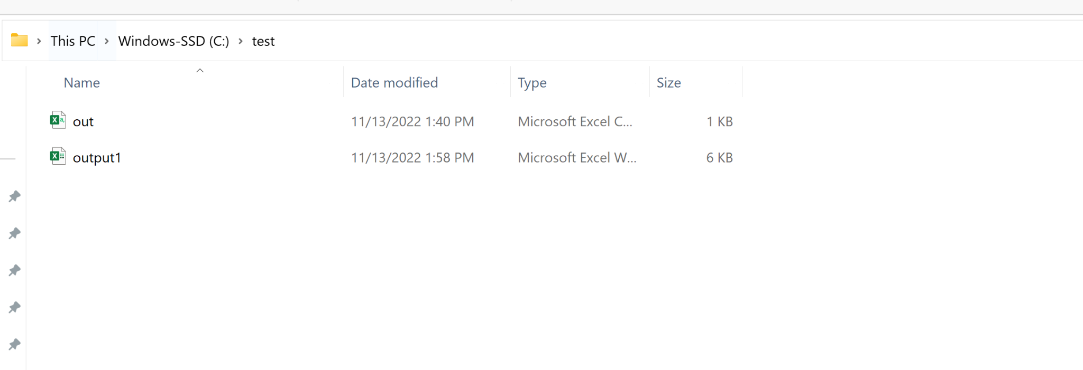

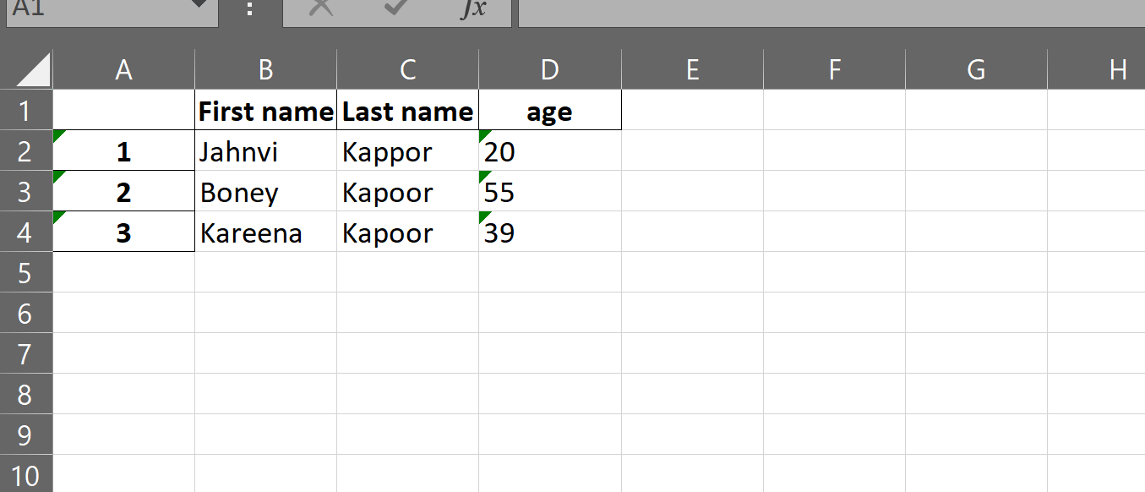

5. You have created a CSV file in #4 above. Now, import data back to Pandas DataFrame from Excel file using Pandas read_excel() function and adding the index_col as a parameter. Show the code and display first few rows.

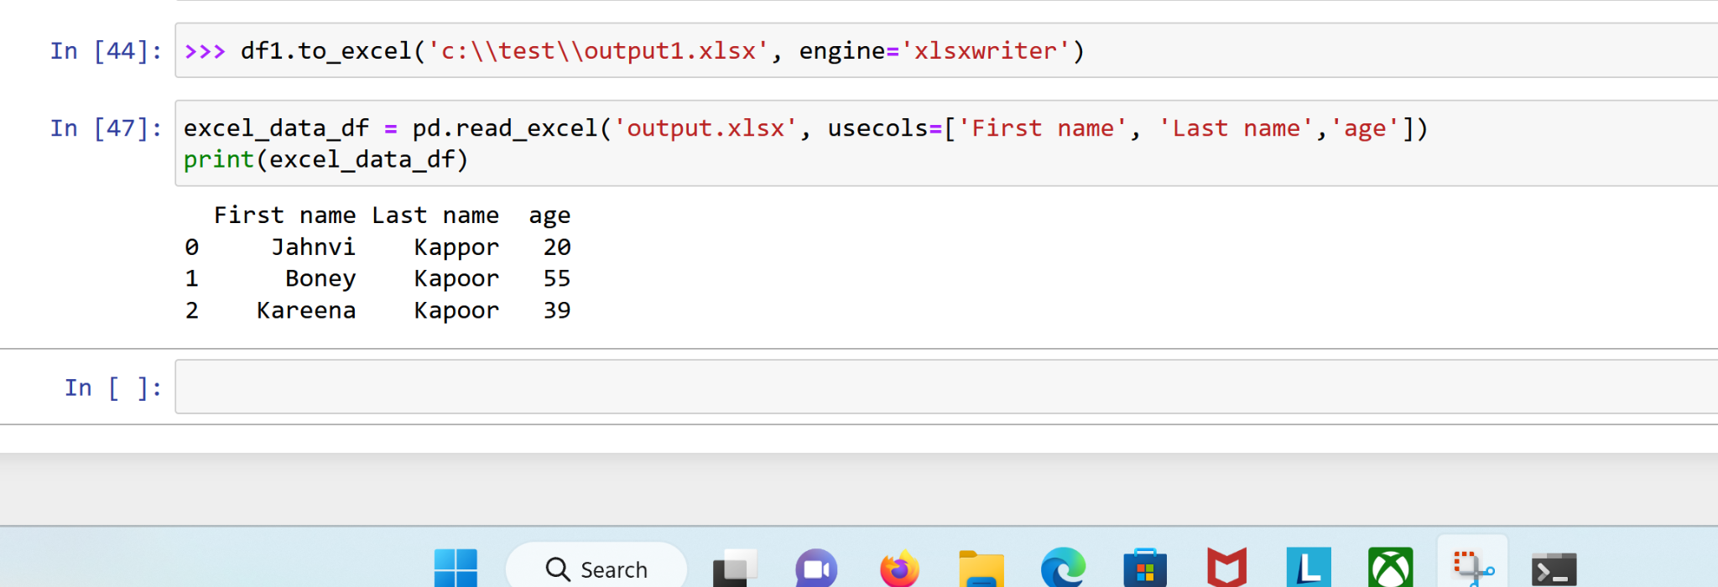
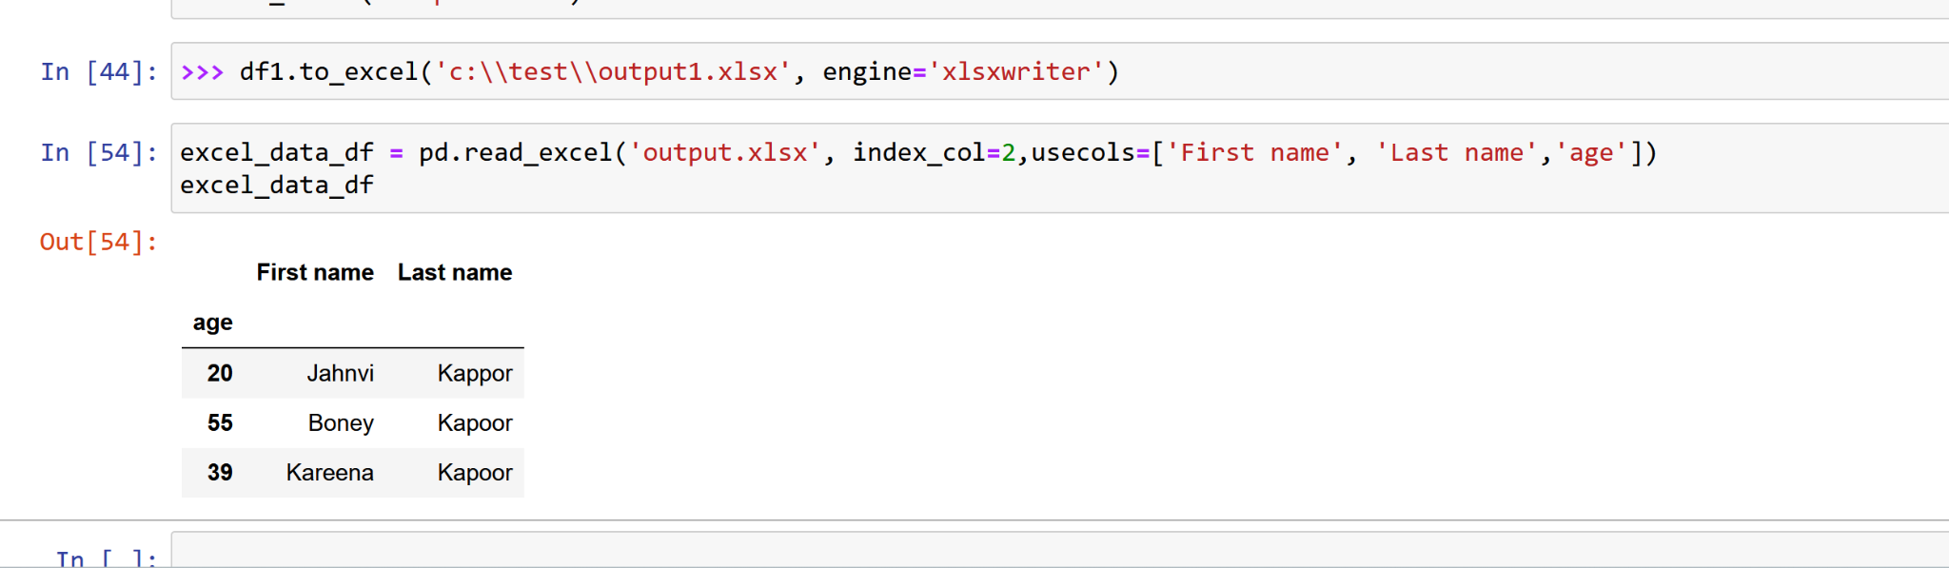
6. You have created an instance of Pandas DataFrame in #1 above. Now, save your Pandas DataFrame to a JSON file with .to_json() function. Show the code. Verify the data.json file created on your C drive! Show the screenshot of the file and a few rows.
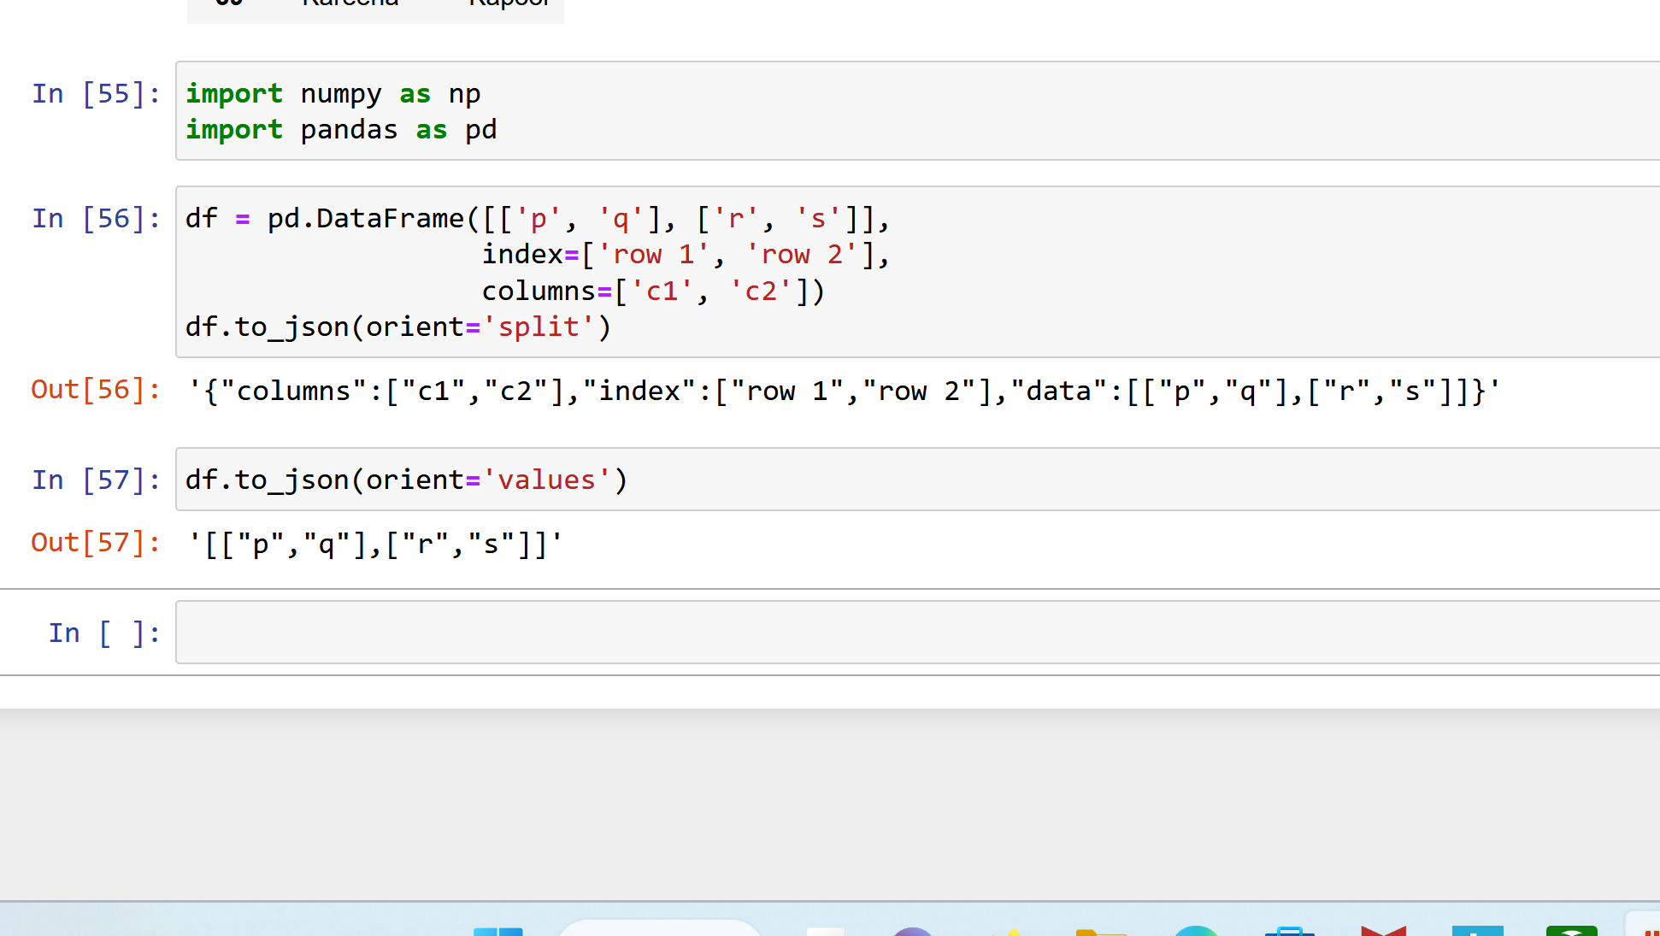
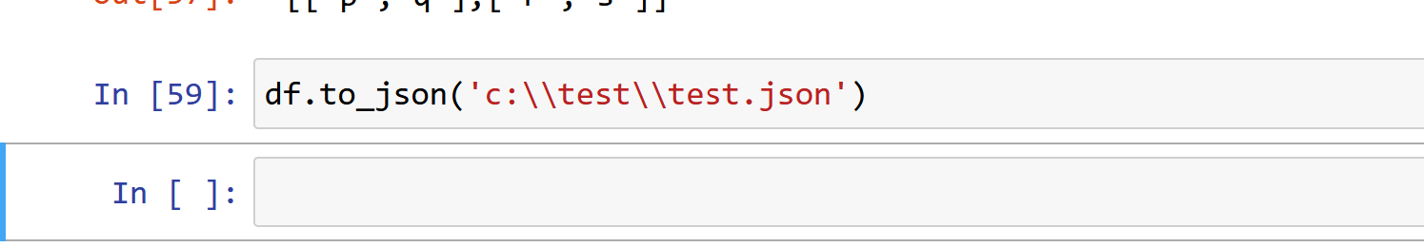
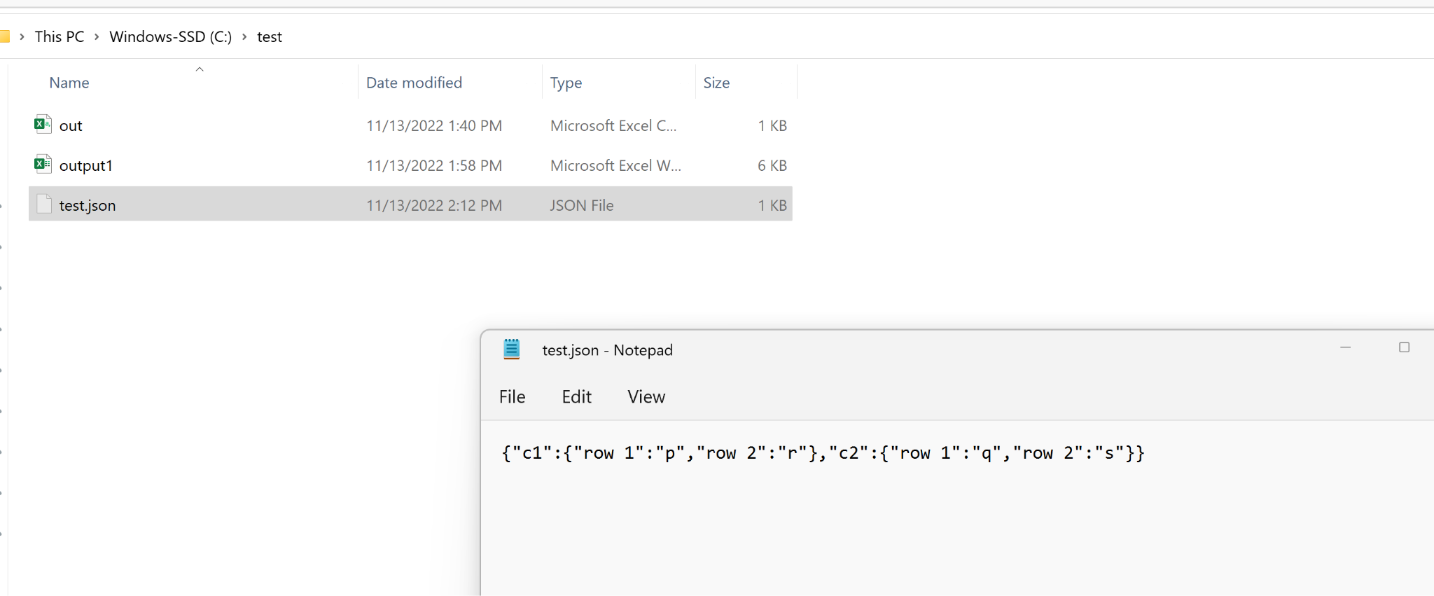
7. You have created a JSON file in #6 above. Now, import data back to Pandas DataFrame from the JSON file using Pandas read_json() function. Show the code and display first few rows.
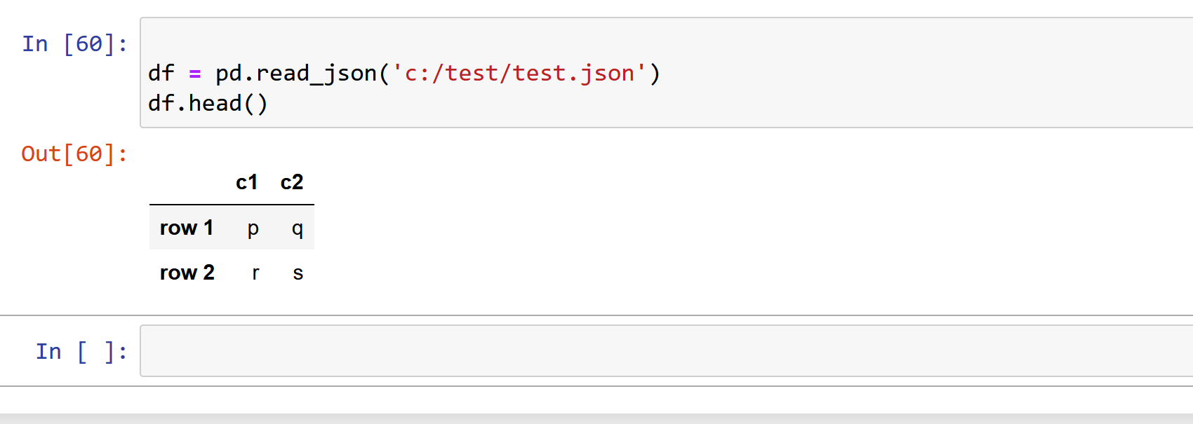
8. You have created an instance of Pandas DataFrame in #1 above. Now, save your Pandas DataFrame to an HTML file with .to_html() function. For this, you need to install lxml html5lib packages [shell: $ conda install lxml html5lib]. Show the code. Verify the data.html file created on your C drive! Show the screenshot and display first few rows.

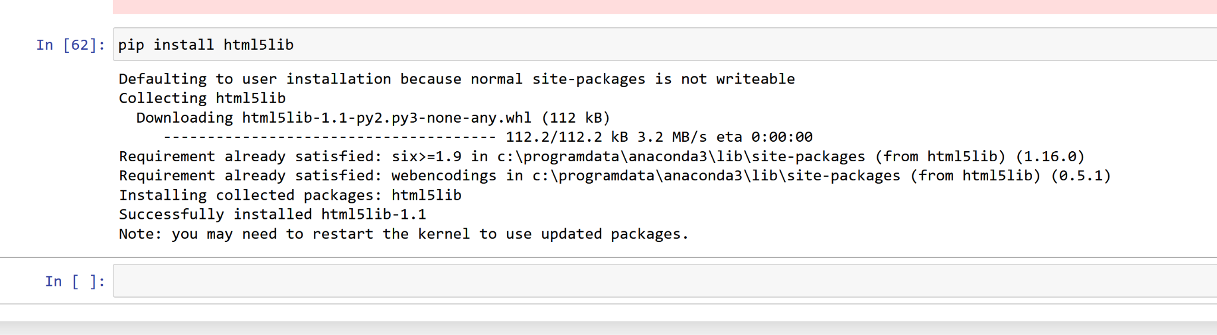
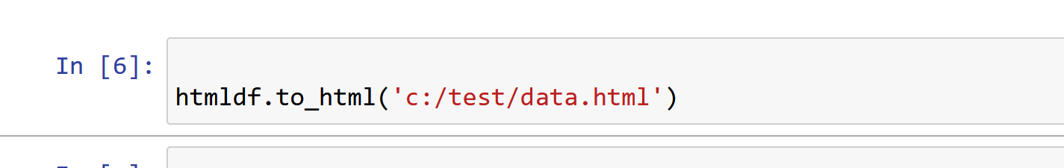
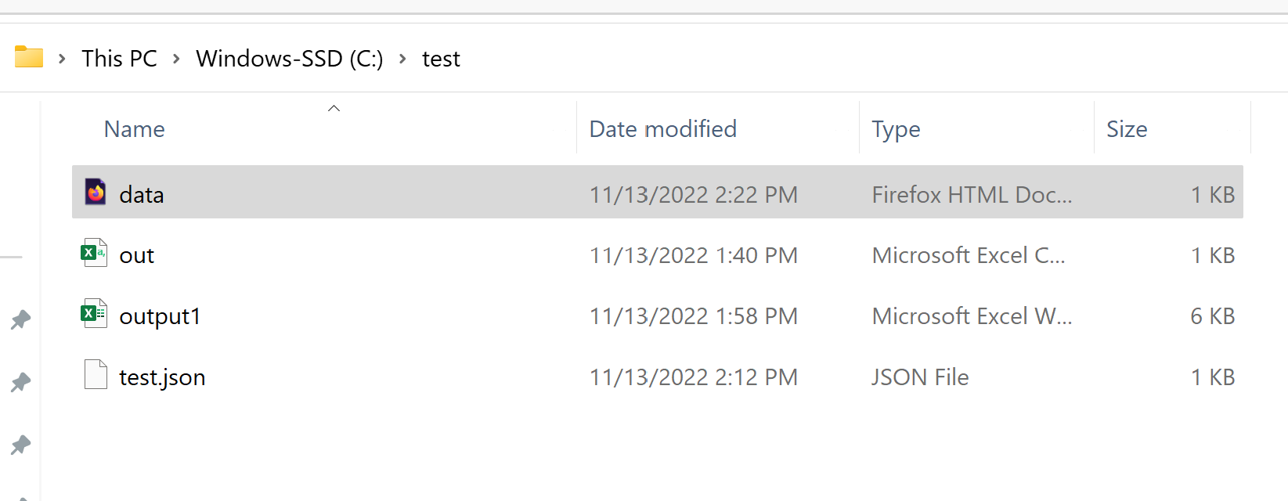
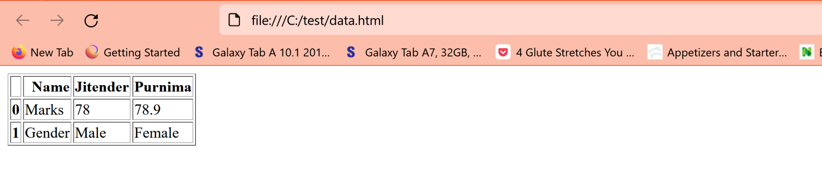
9. Copy some tabular data from a webpage. Now, import data to Pandas DataFrame using Pandas read_clipboard() function. Show the code and display first few rows. Refer to Slide 6 of the presentation slides for more information.
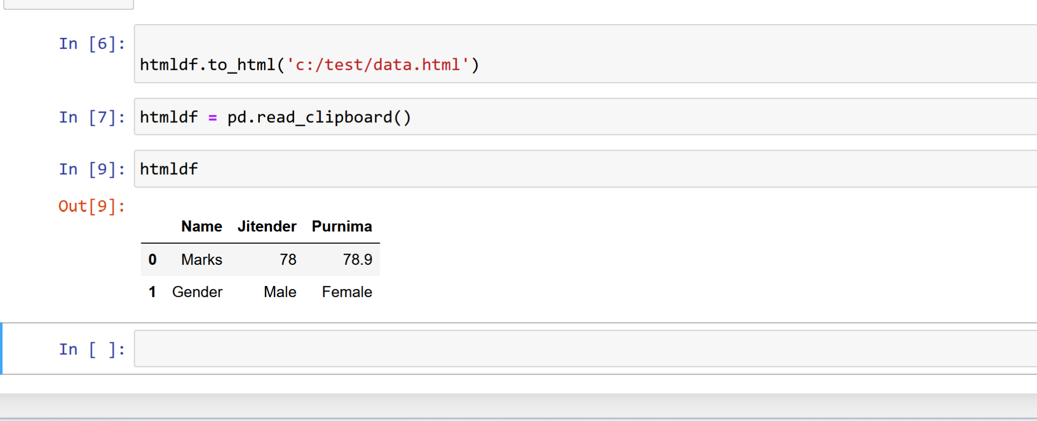
10. Write a Python program to find the 11th to 20th prime numbers. Output the numbers to a data file called prime.txt. Use "w" method (mode) for opening a file. Display the numbers to the notebook. Use "r" method (mode) for opening a file and show results. Demonstrate that you used “continue” and “break” to improve efficiency.
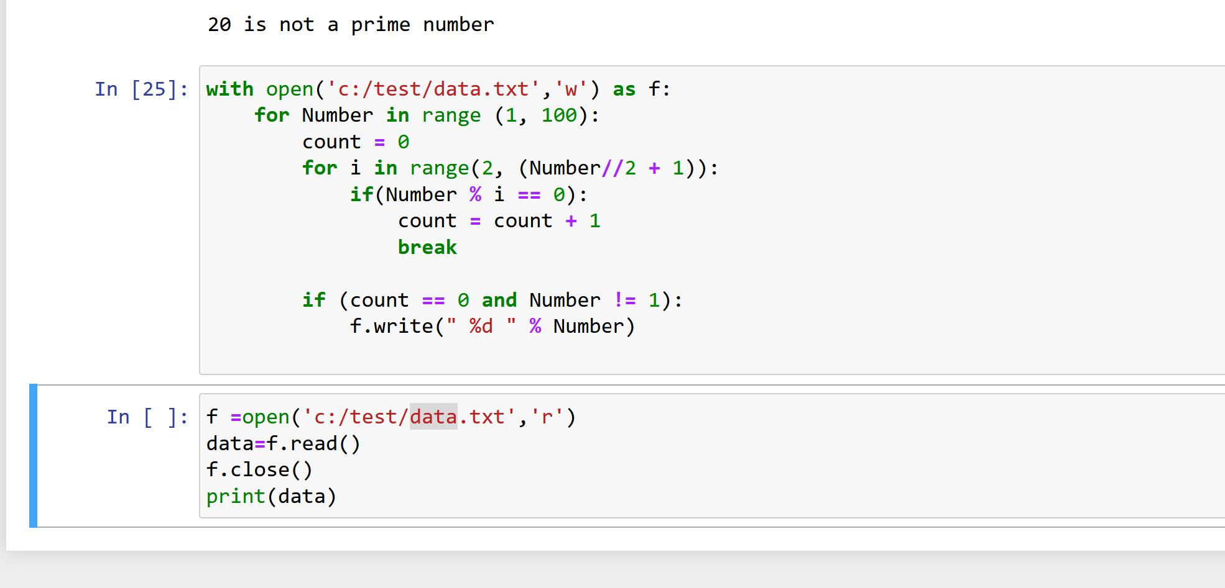
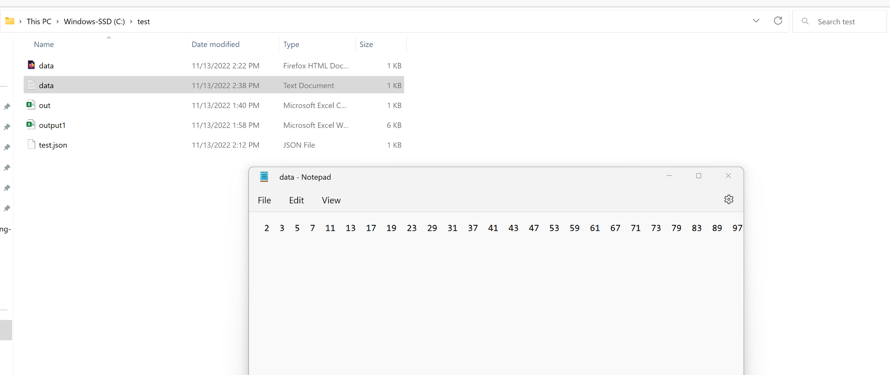
End

